

**“MOBILE BASED ATTENDANCE SYSTEM”**

**SUBMITTED BY:**

**1. BHAVIN R. RANINGA (CO-5I,6I /1815430023) 2. BANDINI G. KOHARE (CO-5I,6I /1715430326) 3.**

**DIGESHWAR P. RAJGADE (CO-5I,6I /1815430017) 4. MADHURI**

**B. KAMBALE (CO-5I,6I /1715430325) 5. ASHISH K. PAGE (CO-5I,6I /19430404)**

**Department of computer engineering**

**Ballarpur Institute of Technology**

**School of Diploma engineering-1543**

**2020-2021**



**Certificate of Project Conformation**

This is to certify that the project entitled

**“Mobile Based Attendance system”** assigned to group **[G-4]** as a part of fulfilment of

Diploma computer engineering on [ date day ] of [day month] [date year]

The project group [G-4] has the following member;

1. BHAVIN R. RANINGA (CO-5I,6I/1815430023)
2. BANDINI G. KOHARE (CO-5I,6I /1715430326)
3. DIGESHWAR P. RAJGADE (CO-5I,6I /1815430017)
4. MADHURI B. KAMBALE (CO-5I,6I /1715430325)
5. ASHISH K. PAGE (CO-5I,6I /1915430404)

The group has to complete the project within the academic schedule under the guidance of

## Project Guide Department

of computer engineering **Prof. Sandhya Paradhi**

**Head of Department Project coordinator**

Department of computer engineering Department of computer engineering

**Prof. Aarti Vaidya**  **Prof. Aarti Vaidya**

**INDEX Chapter 1:**

**Rationale……………………………………………………………………….1**

**Chapter 2: Introduction………………………………………………………………….2-3**

Chapter 3: literature survey 7

Chapter 4: Problem Definition 8

Chapter 5: Requirement (hardware & Software) Analysis Phase……………………...6 9

Chapter 6: Block Diagram …………………………………………………………..7 10

**Chapter7: Advantages……………………………………………………………….........11**

**Chapter 8: project action planning………………………………………………..….12-13**

## Chapter 1 : Rational

Till the last few months, we(students) used to go to colleges and schools physically and study but due to the COVID-19 pandemic all the classes are been conducted through medium online modes (Google meet, Zoom, Google classroom, etc) so recording attendance is a challenge for faculty. Also, before the pandemic maintaining attendance in registers was a tedious task so we are here with a solution for this problem, we have created a website where each student has different login credentials to login their id and marks attendance for the current date. Also, here faculty as well as parents have their own login credentials so faculty can check how many students are present in the class and who are absent and parents can check their child’s attendance to keep an eye on their studies.

This website also consists of other features such as event notifications, message(notice) sending, exam marks record, etc.

**(1)**

## Chapter 2: Introduction Mobile Based Attendance System

Our project aims in implementing software that will help lecturers to take the attendance of students using mobile/Smartphone. Lecturers will login to the phone application and get connected to the server. After login, they will take attendance using mobile phone. After taking the attendance in the mobile, lecturer will send it over to the server using gprs. Lecturer will be able to edit attendance by login to the website and students will check their attendance using a website.

Mobile Based Attendance System application is mainly designed for the faculties and other staff members or organizational heads of the institutes who take attendance of their students and employees regularly. Using this system, all you have to do is to once create a database in this application, of all the students or employees and then you can regularly take attendance of those into your phone only.

This Mobile Based Attendance System is best fitted for those who don’t like to waste their time while taking attendance and also don’t like to miss important time of their students and employees too.

**Existing System:**

We have studied and visited the different websites and the literatures. As per the literature review, the various organizations and individuals have tried to overcome the problems in the traditional attendance system. Some of them are listed below:

Once if your register or the documents related to attendance get lost somewhere, then you will end up losing all the details which will of great loss for both the faculties and students.

Also, it will take a lot of time in marking everyone’s present via hand. Sometimes it does happen that the faculties forget to bring their attendance register and they will take up attendance in page, which in turn will be of a good profit for some student’s as they mark proxy attendance of their friends who are not present on that day.

(2)

**E – Beat:**

E - Beat is an electronic beat constable's night patrolling attendance system to avoid manual recording of time & attendance and to save the time by sign-in / sign-off at different beat points while patrolling. XIPHIAS has developed the Electronic Beat. It has features such as Compact, Light-weight, Pocket size, tamper proof. But it has a limitation regarding system specification. It is operable in fixed temp range i.e., 0 to 70° C. Very small memory storage as small as 64kb.it uses the Infra-Red Serial port for data communication which is outdated.

**Mobile Based Attendance System in J2ME:**

This project is based on J2ME technology. Professor enters the attendance to the mobile using keypad. It is a manual process. After saving the absentees or presenters in to the mobile, teacher can edit the attendance list in the mobile. And this attendance details can send to a computer using GPRS. It was developed considering the requirements of that time and has a very little future scope. The system has a limited bound. It lags behind a lot as when compared to modern day technology such as Windows, Android, iphone .it also a platform dependent and version specific. It does not support the GPS technology to reduce the fake attendance.

**Proposed System:**

Regarding the above literature research and taking in to consideration its drawbacks and limitations, we proposed the, Mobile Phone Based Attendance System in android‟. In this proposed system we are going to develop an android application which will eliminate all the drawbacks of the existing system, which consist of the, **following dynamic features:**

* Time saving as attendance can be taken just by checking the list of students  No needs to maintain several separate records and manual calculations.
* 24x7 availability of information.
* More secured than traditional attendance system.
* A step towards the futuristic e-schools

**(3)**

# Chapter 3: Literature survey

We have studied several papers based on Attendance Management System. First paper we have studied is named as “Biometric Based Attendance” which has published by Mr. Yash Mittal, Ms. Prachi Agrawal and Mr. Kapil Matani. In this paper Biometric scaled up for real time deployment, it provides solution of late coming. The second paper named as “Finger Based Attendance Management with SMS Alert to Parents” which is published by Ms. Poonam Choudhary, Prof.G.N. Dhoot and Mr. Sopan Borale. This paper introduced system include terminal fingerprint module and attendance module and SMS system for alerting parents for updating about their child. The third paper named as “Smart attendance Management and Learning System” which is published by Prof. H.B. Sale, Priyanka Shelake, Tufail Siddhiqui. This paper facility of notes dictation, defaulter list, notes view, notification, details view for students, staff, teachers and Admin. The fourth paper named as “Key Authentication Based Door Lock Monitoring System “Which is published by Chinmay Kulkarni, Avinash Bagul and Pranamya Korde.This project is concentrate more on automation of institute security provides lesser security than actual physical security. The fifth paper named as “Employee Attendance Monitoring System Using radio frequency Identity Card” Which is published by S. Mohan Kumar, Sanjay Chandran, Tamil Selvan and Ajith Kumar. Facilitates automatic wireless identification using ID tags and reader method.

**`**

**(4)**

# Chapter 4: Problem definition

Earlier system existing already was containing redundant duplicate data

System we are developing will reduce the manual work and avoid redundant data.

In the earlier system attendance was maintained manually so it was difficult to generate and efficient report

Here we can generate efficient weekly consolidated report based on the attendance

In the earlier system attendance was maintained in register so it was a tedious task to maintain for long time

Here in this software, we can keep data for the longer time and can retrieve it when required.

### (5)

# Chapter 5: Requirement (hardware & Software) Analysis Phase

**Software Requirements:**

* Android software development kit (SDK)
* Windows XP and above
* Java Development Kit (JDK)
* Notepad
* Android debug bridge\
* Elementor

**Hardware Requirements:**

* Hard Disk – 2 GB.
* RAM – 1 GB.
* Processor – Dual Core or Above.
* Internet connection.
* Mouse.
* Keyboard.
* Monitor.

**(6)**

# Chapter 6: Block Diagram

**Block Diagram (Data Flow Diagram):**

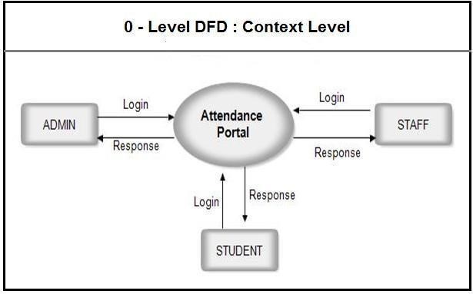

**(7)**

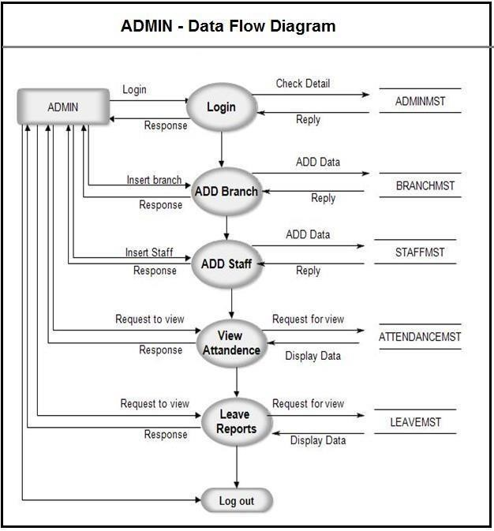

**(8)**

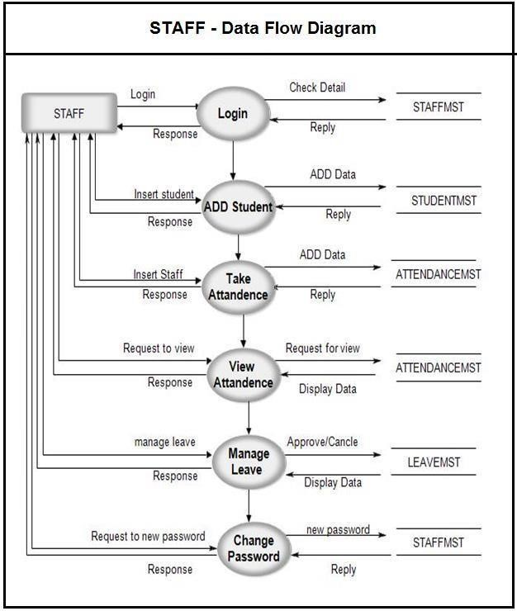

**(9)**

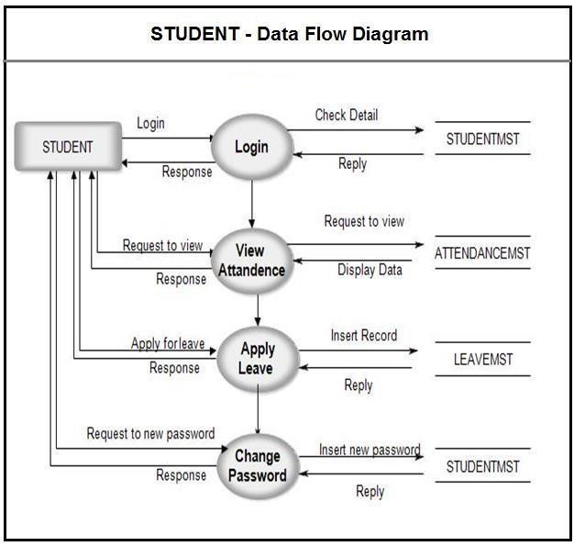

**(10)**

## Chapter 7: Advantages

**Advantages:**

* The file can be transferred from mobile to computer or server via Internet.
* This gives the overall performance of class in attendance.
* There is no need for laptop or computer in every class to run the system as the system can run on mobile so no extra efforts and resources required.
* The website is easy to use
* This website will definitely reduce the human efforts and make task of user with secure login
* **Secure**: You can secure each layer separately using different methods.
* **Easy to manage**: You can manage each layer in system separately, adding or modifying each layer without affecting the other layer in system
* **Scalable**: If you need to add more resources, you can do it per tier, without affecting the other tiers.
* **Flexible**: Apart from isolated scalability, you can also expand each tier in any manner that your requirements dictate.

**(11)**

## Chapter 8: project action planning

**Modules 1.User Module**

The main purpose of the user module is to provide security. This module is specially designed for staffs, which use mobile phone to take attendance. Each staff enter username and password before enter in to attendance list. If username and password cannot match, he/she can enter in to attendance page.

1. **Attendance Entry Module**

The purposes of Attendance Entry Module is to enter the attendance using cell phone. In this module Lecturer takes the attendance using the cell phone. Lecturers select the branch, semester and year. After this session he enters in to attendance page. Here staff makes a mark on the absentees

1. **GPRS Connectivity Module**

The main function of GPRS connectivity module is sends attendance list to the server database by connecting cell phone with the server through GPRS. In this module attendance list in the cell phone is sends to the database.

1. **Database Module**

The first function of this module is to update the attendance list from the cell phone. When the attendance list from the cell phone receives, server automatically updates its database. The server updating the database whether any change from cell phone occurred.

1. **Location Detection Module**

This module helps in restricting fake attendance. The lecturer cannot take attendance from anywhere else when he/she is actually not present in the class. It will be completed within 20 days.

1. **Email Module**

This module is used to send email to the students about their attendance, curriculum activities.

**(12)**

**The project Mobile based attendance system contains the given modules:**

1. **Faculty Module:** This module contains the profiles of all the faculties and faculties have to login into their account in order to mark the attendance. Faculties can work whenever they wish and can change the module as per their choice.
2. **Students Module:** All the names and attendance mark-ups are added in this module. Students module is mainly used for entering details about the students. And no faculty detail involvement is requiring in this module.
3. **Attendance Module:** All the details related to attendance are present at one module and it is known to be an attendance module.
4. **Overview Module:** When the attendance is not being taken and when were the holidays come and went and all the details related to this as present in this module.

### (13)